Screenshots

03 October 2024

Natalia Palej

A00279259

Software Design with Artificial Intelligence for Cloud Computing Year 4

Lab 3

## Step 3: Configure the PC – PC IP SET UP

## Sending Simple Test Messages in Realtime and in Simulation Mode – Successful Simple PDU

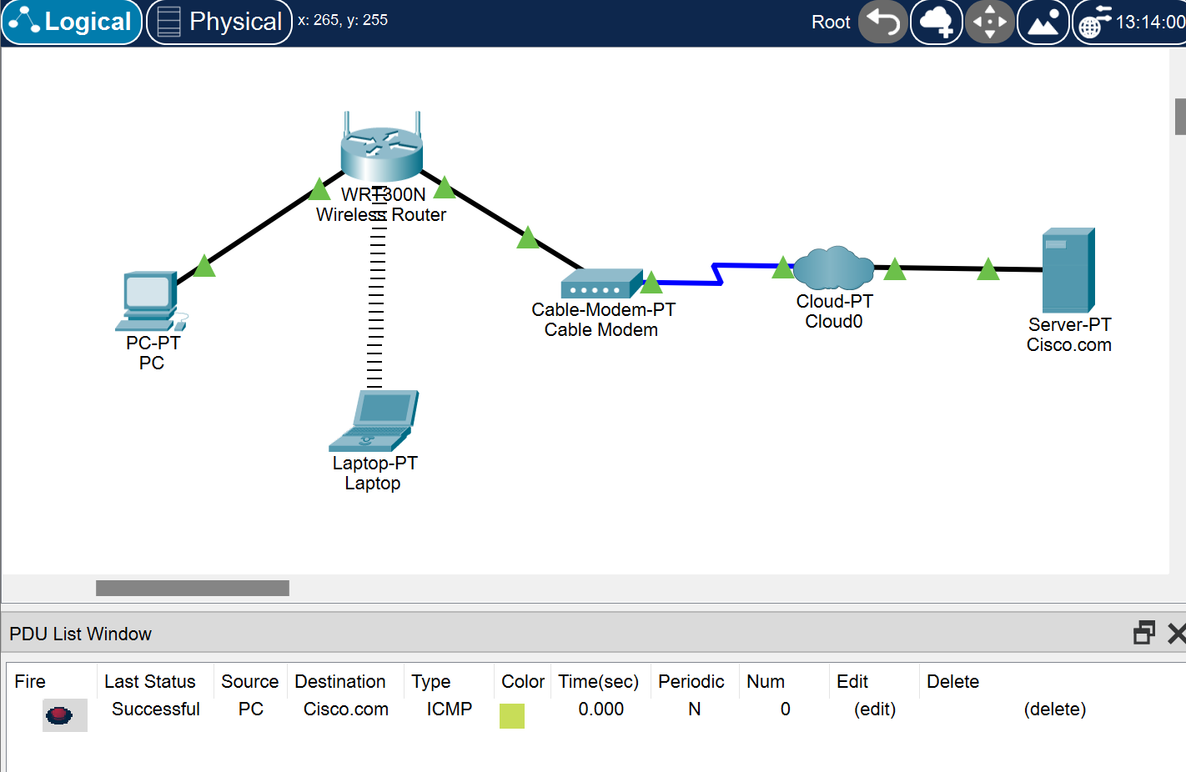

## PDU – ICMP Ping Response

